Follow-on thoughts to Rabbi Jonathan Cahn's 9/11 Harbinger – I believe an additional harbinger was evidenced on September 11, 2011 which went largely un-noticed. To get the full impact of what is presented herein, one must read AND view all the material and video clips linked, and make your own decision as to the findings presented. Many of the excerpts below were originally part of blogging comments I made on certain end-time events websites, thus the postings herein and comments are not in any particular order. ~A Watchman
If you are not familiar with Cahn's 9/11 Harbinger teaching, see a short re-cap here http://www.wnd.com/2011/12/379829/

On September 11, 2011 President Barack Obama read from Psalm 46 as part of the ceremony at the World Trade Center site to mark the 10th anniversary of the Sept. 11, 2001, attacks. (Sept. 11)

A must watch & listen: http://www.youtube.com/watch?v=VxFj4mv0rRQ

=======================

Reading Psalm 46 just does not foot with everything else he has done, is doing, and who he really is (which we don't really know, since most of his past seems to be blocked) - he is such an extreme narcissist that I would dare say (to point out the obvious) he seemed to be talking about himself in many of the verses he read, these three stand out:

Be still and know that I am God.
I will be exalted among the nations.
I will be exalted in the Earth.

Seemed like a narcissistic forth-telling, his own look into the future.
O has been sounding a lot like (or maybe a type of):

The Man of Lawlessness - 2 Thessalonians 2

1 Concerning the coming of our Lord Jesus Christ and our being gathered to him, we ask you, brothers and sisters,
2 not to become easily unsettled or alarmed by the teaching allegedly from us— whether by a prophecy or by word of mouth or by letter—asserting that the day of the Lord has already come.
3 Don’t let anyone deceive you in any way, for that day will not come until the rebellion occurs and the man of lawlessness is revealed, the man doomed to destruction.
4 He will oppose and will exalt himself over everything that is called God or is worshiped, so that he sets himself up in God’s temple, proclaiming himself to be God.
5 Don’t you remember that when I was with you I used to tell you these things?
6 And now you know what is holding him back, so that he may be revealed at the proper time.
7 For the secret power of lawlessness is already at work; but the one who now holds it back will continue to do so till he is taken out of the way.
8 And then the lawless one will be revealed, whom the Lord Jesus will overthrow with the breath of his mouth and destroy by the splendor of his coming.
9 The coming of the lawless one will be in accordance with how Satan works. He will use all sorts of displays of power through signs and wonders that serve the lie,
10 and all the ways that wickedness deceives those who are perishing. They perish because they refused to love the truth and so be saved.
11 For this reason God sends them a powerful delusion so that they will believe the lie
12 and so that all will be condemned who have not believed the truth but have delighted in wickedness.

(What is to be our response) Stand Firm

13 But we ought always to thank God for you, brothers and sisters loved by the Lord, because God chose you as first fruits to be saved through the sanctifying work of the Spirit and through belief in the truth.
14 He called you to this through our gospel, that you might share in the glory of our Lord Jesus Christ.
15 So then, brothers and sisters, stand firm and hold fast to the teachings[c] we passed on to you, whether by word of mouth or by letter.
16 May our Lord Jesus Christ himself and God our Father, who loved us and by his grace gave us eternal encouragement and good hope,
17 encourage your hearts and strengthen you in every good deed and word.

=======================
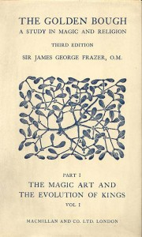
I know anyone could miss a pronunciation, but O pronounced bow incorrectly as bough. O's mis-pronunciation of 'bow" as "bough" could be VERY significant per my research!

In looking into the word "bough" I found "The Golden Bough" A Study in Magic and Religion.
The Golden Bough attempts to define the shared elements of religious belief, ranging from ancient belief systems to relatively modern religions such as Christianity. Its thesis is that old religions were fertility cults that revolved around the worship of, and periodic sacrifice of, a sacred king. This king was the incarnation of a dying and reviving god, a solar deity who underwent a mystic marriage to a goddess of the earth, who died at the harvest, and was reincarnated in the spring. Frazer claims that this legend is central to almost all of the world's mythologies. The germ for Frazer's thesis was the pre-Roman priest-king at the fane of Nemi, who was ritually murdered by his successor:
Preface to Frazer's The Golden Bough

In this sacred grove there grew a certain tree round which at any time of the day, and probably far into the night, a grim figure might be seen to prowl. In his hand he carried a drawn sword, and he kept peering warily about him as if at every instant he expected to be set upon by an enemy.

He was a priest and a murderer; and the man for whom he looked
was sooner or later to murder him and hold the priesthood in his stead.

Such was the rule of the sanctuary.

[One could look at this statement two ways, the AC is murdered 3.5 yrs into the Tribulation and Satan takes his place, appearing to raise him from the dead and with the antichrist continues their counterfeit priesthood, and, isn't this exactly what is going to happen when Christ finally settles the account with the antichrist and King Jesus the Messiah as "the priest forever in the order of Melchizedek" (Ps. 110:4), plays the role of High Priest once and for all.]

Also...a reference in http://en.wikipedia.org/wiki/Cornerstone is interesting pertaining to the FreeMason Cornerstone:

Often, the ceremony involved the placing of offerings of grain, wine and oil on or under the stone. These were symbolic of the produce and the people of the land and the means of their subsistence. This in turn derived from the practice in still more ancient times of making an animal or human sacrifice that was laid in the foundations.

Frazer (2006: p. 106-107) in The Golden Bough charts the various propitiary sacrifices and effigy substitution such as the shadow, states that:

Nowhere, perhaps, does the equivalence of the shadow to the life or soul come out more clearly than in some customs practiced to this day in South-eastern Europe. In modern Greece, when the foundation of a new building is being laid, it is the custom to kill a cock, a ram, or a lamb, and to let its blood flow on the foundation-stone, under which the animal is afterwards buried. The object of the sacrifice is to give strength and stability to the building. But sometimes, instead of killing an animal, the builder entices a man to the foundation-stone, secretly measures his body, or a part of it, or his shadow, and buries the measure under the foundation-stone; or he lays the foundation-stone upon the man's shadow. It is believed that the man will die within the year. The Roumanians of Transylvania think that he whose shadow is thus immured will die within forty days; so persons passing by a building which is in course of erection may hear a warning cry, Beware lest they take thy shadow! Not long ago there were still shadow-traders whose business it was to provide architects with the shadows necessary for securing their walls. In these cases the measure of the shadow is looked on as equivalent to the shadow itself, and to bury it is to bury the life or soul of the man, who, deprived of it, must die. Thus the custom is a substitute for the old practice of immuring a living person in the walls, or crushing him under the foundation-stone of a new building, in order to give strength and durability to the structure, or more definitely in order that the angry ghost may haunt the place and guard it against the intrusion of enemies.

[not hard to see how this could all fit!]

So now back to O's parapraxis"

He breaks the bough and cuts the spear in two.
He burns the chariot in fire.
Be still and know that I am God.

=======================

See for yourself the actual transcript of O's reading of Psalm 46 still printed on the Whitehouse.gov website http://www.whitehouse.gov/blog/2011/09/11/president-obama-and-first-lady-join-services-commemorate-tenth-anniversary-911
It has the same miss-spelling <sic> on the actual transcript...it says bough! This was not a mistake!
=======================

Posted Friday 31, 2008 (pre-election) http://webcache.googleusercontent.com/search?q=cache:hcFZqUuJuo8J:thedailyrepublican.com/index.php%3Foption%3Dcom_content%26task%3Dview%26id%3D2044%26Itemid%3D26+&cd=2&hl=en&ct=clnk&gl=us&client=safari
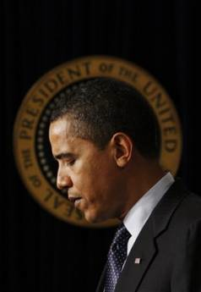

AP
Golden Bough: Barack Obama has published two wellcrafted memoirs but will a victory spell a new era in American literature?
(very interesting use of words from the AP in 2008 - Obama Golden Bough)

=======================

O' reminds me of....

"Powerful you have become, Dooku. The dark side I sense in you."

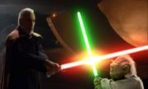

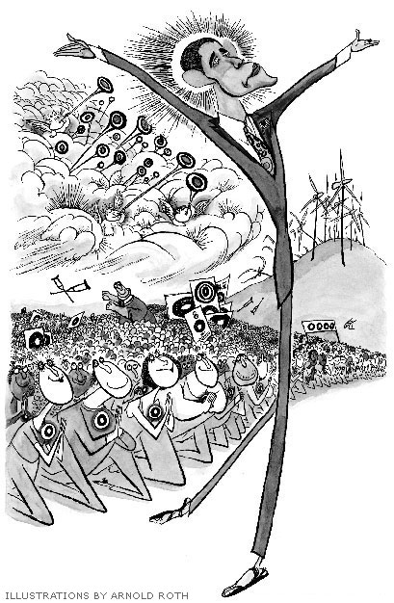
=======================
http://archive.frontpagemag.com/readArticle.aspx?ARTID=31646
July 14, 2008

In the patois of punditry, “charismatic” has come to mean little more than “like a rock star.” But the striking thing about the charismatic leader is the extent to which his followers regard him as a healer of wounds, an alleviator of pain. In this sense, surely, Senator Barack Obama is charismatic. The carefully knotted ties and the dark, conservatively tailored suits only accentuate the exoticness of his shamanism; he has entered the American psyche not as a hero but as a healer. [Hummm...sounds like Obama Golden Bough]

The country, or much of it, has longed for such a figure, a man from the once-oppressed race whose rise to power will atone for the sins of slavery and racial stigmatization. But Obama’s rhetoric encompasses more than a promise of racial healing. He is not the first politician to argue that politics can redeem us, but in posing as the Adonis who will turn winter into spring, he revives one of the more pernicious political swindles: the belief that a charismatic leader can ordain a civic happy hour and give a people a sense of community that will make them feel less bad.

In his unfinished treatise Economy and Society, Max Weber defined charisma as “a certain quality in an individual personality by virtue of which he is set apart from ordinary men and treated as endowed with supernatural, superhuman, or at least specifically exceptional powers or qualities.” Weber was able to do little more, before he died in 1920, than give a pseudoscientific élan to an idea that had been kicking around for centuries. Most of what he said about charismatic authority was stated more cogently in Book III of Aristotle’s Politics, which described the great-souled man who “may truly be deemed a God among men” and who, by virtue of his greatness, is exempt from ordinary laws. [WOW, who does this sound like!]

What both Aristotle and Weber made too little of is the mentality of the charismatic leader’s followers, the disciples who discover in him, or delusively endow him with, superhuman qualities. “Charisma” was originally a religious term signifying a gift of God: it often denotes (according to the seventeenth-century scholar-physician John Bulwer) a “miraculous gift of healing.” James G. Frazer, in The Golden Bough, demonstrated that the connection between charismatic leadership and the melioration of suffering was historically a close one: many primitive peoples believed that the magical virtues of a priest-king could guarantee the soil’s fertility and that such a leader could therefore alleviate one of the most elementary forms of suffering, hunger. The identification of leadership with the mitigation of pain persists in folklore and myth. In the Arthurian legends, Percival possesses an extraordinary magic that enables him to heal the fisher king and redeem the waste land; in England, the touch of the monarch’s hand was believed to cure scrofula.

=======================

Obama Messianism

www.nationalreview.com/liberal-fascism/203769/obama-messianism
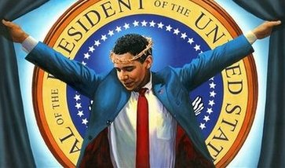

July 14, 2008
Basically the same article as above with a different title "Obama Messianism"

[Is Barack Obama, taking up the part of regenerative healer...]

=======================

Ok...so it looks like the "Bough" vs bow is starting to fit as not just a mistaken mispronunciation - whether he meant to say it or not!

In my search for other sources where O has been compared to The Golden Bough, I also stumbled on this:

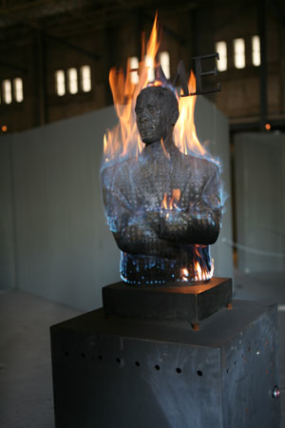

Liu Bolin, “Burning Man Obama”, 2009, Bronze and pyrotechnics

Somehow seems to fit this post
“And the devil that deceived them was cast into the lake of fire and brimstone, where the beast and the false prophet are, and shall be tormented day and night for ever and ever.” Revelation 20:10

=======================

Who Are the people behind O?

Ah yes, that is a very good question "Who are these people".....

http://www.youtube.com/watch?v=MouUJNG8f2k&feature=player_embedded
Keep in mind when listening to this, it was recorded in the early part of November 2008 (pre-election)...on a look back, this guy appears to be spot on with almost all of what he says.

=======================

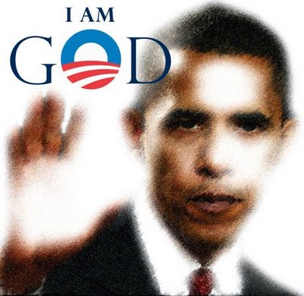

=======================

In thinking further about the sculpture by Chinese artist Liu Bolin titled "Burning Man Obama" I found it was tested at a workshop in Beijing November 11, 2009 (11/11/09). The sculpture is to "represent President Barack Obama's impact on the world."

Could this be a message in itself? (same as what I will point out below) 11/11/2009 or 11+11+2+9 = 33 and likely some tie-in with 9/11 with the same numbers in reverse.

From my prior post, I realized July 14, 2008 was the first mention of the tie-in of O and (and being) The Golden Bough...it was actually in two articles that same day:
http://archive.frontpagemag.com/readArticle.aspx?ARTID=31646
and Obama Messianism http://www.nationalreview.com/liberal-fascism/203769/obama-messianism

If you start at July 14, 2008 to the election day of O on November 4, 2008, it is exactly 113-days or 11 x 3 = 33 ... In numerology the number 33 has the meaning of "The Master Healer" additionally, 11, 13 and 33 is the Illuminati / Freemason Signature
www.theforbiddenknowledge.com/hardtruth/13_33_freemason_sig.htm
They have a long history of staging events to correspond to, or point at certain numbers as a signal to the enlightened.

Back to the 113-days, [11, 13 and 33 is the Illuminati / Freemason Signature] it has all three numbers represented 11 and 13 and 11x3=33

O is next mentioned again in the context of The Golden Bough on "All Saints Day" Oct 31st, 2008, 4 days prior to the election (undoubtedly as another Illuminati message)
http://webcache.googleusercontent.com/search?q=cache:hcFZqUuJuo8J:thedailyrepublican.com/index.php%3Foption%3Dcom_content%26task%3Dview%26id%3D2044%26Itemid%3D26+&cd=2&hl=en&ct=clnk&gl=us&client=safari
=======================

Sackcloth&Ashes911EMERGENCY BROADCAST False Messiah/Son of Perdition Declares he is GOD (Good Video!)

www.youtube.com/watch?v=svDmhqLAYlg&feature=player_embedded

=======================

As the TV sales pitch goes "But Wait, There's More"

From Oct 29, 2008 Hosannah, Obama!
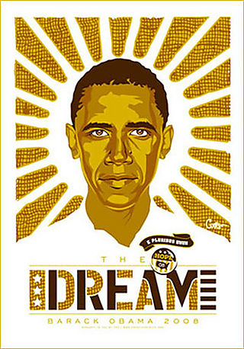

Caption: If it's not the slightly communist overtones of his "Hope" flyers being glued all over my city, it's the Messianic-Corn pictures hanging in store-front windows. Maranatha! Come, Barack, the Lord!

In the Comments section someone wrote: Wow... my first thought was of Frazer's Golden Bough, where he compares the myths of the Corn King and the Messiah... the Obamessiah is clearly the culmination of all of that!
Source: http://beingornothingness.blogs.com/living/2008/10/hosannah-obama.html

And...

FEBRUARY 12, 2008 (now the earliest record I have found of the Golden Bough comparison (266 days prior to election) and the most eye opening....also, Feb 12, 2008 = 2/12/2008 or 2122008 2+1+2+20+8 = 33 (33 surfaces again!).

Read this slowly (printed below) and let it sink in:

Obama: The Sorcerer's Method Behind the Madness
http://americandigest.org/mt-archives/intellectually_insane/chapter_3_sympa.php

"Come on home, girl,"
He said with a smile
"You don't have to love me yet,
Let's get high awhile.
But try to understand,
Try to understand,
Try, try, try to understand
I'm a magic man." -- Heart

"In savage society there is commonly to be found in addition what we may call public magic, that is, sorcery practiced for the benefit of the whole community. Wherever ceremonies of this sort are observed for the common good, it is obvious that the magician ceases to be merely a private practitioner and becomes to some extent a public functionary.

"The development of such a class of functionaries is of great importance for the political as well as the religious evolution of society. For when the welfare of the tribe is supposed to depend on the performance of these magical rites, the magician rises into a position of much influence and repute, and may readily acquire the rank and authority of a chief or king.

"The profession accordingly draws into its ranks some of the ablest and most ambitious men of the tribe, because it holds out to them a prospect of honor, wealth, and power such as hardly any other career could offer. The acuter minds perceive how easy it is to dupe their weaker brother and to play on his superstition for their own advantage.

"Not that the sorcerer is always a knave and impostor; he is often sincerely convinced that he really possesses those wonderful powers which the credulity of his fellows ascribes to him. But the more sagacious he is, the more likely he is to see through the fallacies which impose on duller wits.

"Thus the ablest members of the profession must tend to be more or less conscious deceivers; and it is just these men who in virtue of their superior ability will generally come to the top and win for themselves positions of the highest dignity and the most commanding authority.

"The pitfalls which beset the path of the professional sorcerer are many, and as a rule only the man of coolest head and sharpest wit will be able to steer his way through them safely. For it must always be remembered that every single profession and claim put forward by the magician as such is false; not one of them can be maintained without deception, conscious or unconscious.

Accordingly the sorcerer who sincerely believes in his own extravagant pretensions is in far greater peril and is much more likely to be cut short in his career than the deliberate impostor.

"The honest wizard always expects that his charms and incantations will produce their supposed effect; and when they fail, not only really, as they always do, but conspicuously and disastrously, as they often do, he is taken aback: he is not, like his knavish colleague, ready with a plausible excuse to account for the failure, and before he can find one he may be knocked on the head by his disappointed and angry employers."

All Text from Chapter 4. The Magician's Progress. Frazer, Sir James George. The Golden Bough 1922.

[All this sure sounds like our Narcissist in Chief, our Golden Bough healer]

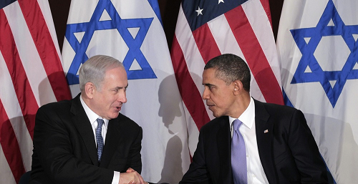
=======================

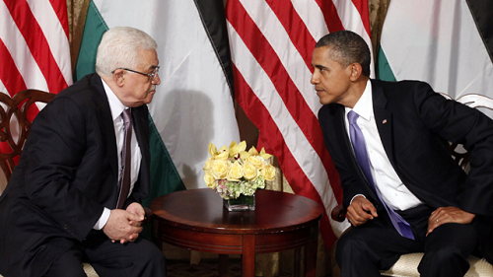
Netanyahu and Obama met in New York on Wednesday Photo / AP

Abbas and Obama also met in New York on Wednesday - Photo/Fox News

Call me crazy, but sure looks like O is the point person to strike a Peace agreement in the Mideast...let's rewind to the Nobel Peace Prize of 2009.


The Nobel Peace Prize 2009 was awarded to Barack H. Obama "for his extraordinary efforts to strengthen international diplomacy and cooperation between peoples".

Accepting Nobel, Obama vows to pursue Mideast peace
U.S. President Barack Obama reiterated on Friday his commitment to resolving the Israeli-Palestinian conflict, in a short speech he made during which he expressed surprise over winning the 2009 Nobel Peace Prize.

"We must all do our part to resolve those conflicts that have caused so much pain and hardship over so many years," Obama told reporters in the White House Rose Garden.

"And that effort must include an unwavering commitment that finally realizes that the rights of all Israelis and Palestinians to live in peace and security in nations of their own."

Obama said he accepted the honor as a call to action for nations to confront the challenges of the century... http://www.haaretz.com/news/accepting-nobel-obama-vows-to-pursue-mideast-pease-1.6375

Bin Laden Killing Gives Obama Clout in Middle East Peace Deal
http://www.usnews.com/opinion/blogs/stephen-glain/2011/05/06/bin-laden-killing-gives-obama-clout-in-middle-east-peace-deal

With the deletion of the world’s most wanted terrorist, the deleter in chief should invest his newfound diplomatic and political capital in the Levantine Middle East, where the whirlwind of political unrest is sowing opportunities for a peace deal.

This week, Palestinian factions Fatah and Hamas reconciled after four years of estrangement. As part of a unity government, Hamas will honor the Palestinian Authority’s peace agreements with Israel and Fatah officials will lead the new government in negotiations with the Jewish state for an independent Palestine. This is a position Hamas would never have assumed two decades ago, when Yasser Arafat negotiated an historic peace deal with Israel, nor is it the first time it has made such a concession....

...President Barack Obama now has the leverage he needs to impose the framework of a Levantine peace deal, and it should include recognition of Hamas as a legitimate constituency within the Palestinian electorate. He can do this covertly, through neutral third parties, or as part of a very public multilateral round that involves countries like Egypt and Turkey.

=======================

The Story of Obama and Israel
President Obama has consistently and blatantly been the most anti-Israeli and and anti-Jewish president this country has ever seen. It's easy to see why in Israel's hour of need, during the War of Gog and Magog, that America will do nothing to help, only asking the Russian and Iranian led armies why they have come to plunder and loot Israel. Please watch this video and share with your friends and family...http://www.youtube.com/watch?feature=player_embedded&v=0wbH5KVPrPo [A must watch for every God fearing American...answers for me why America may be conspicuously absent in (the Bible for) end-time events - Joel 3:2 says some day God will bring judgment upon all nations because they divided up Israel]

Also read: The Striped Leopard
We've crossed the delusional threshold...The mystery of lawlessness is already at work -- and for most of us, the more lawlessness increases, the more mysterious it becomes...http://www.omegaletter.com/briefs/briefings.asp?BID=3389
and: America’s Most Biblically-Hostile U.S. President
His actions are literally unprecedented - this is the first time they have happened in four centuries of American history. The hostility of the President toward Biblical faith and values is without equal from any previous American president...Listed in chronological order are: (1) numerous records of attacks on Biblical persons or organizations; (2) hostility toward Biblical faith in the military; (3) a listing of his open attacks on Biblical values; (4) a listing of numerous incidents of his preferential deference for Islam’s activities and positions, including his hostility toward people of Biblical faith...http://www.bibleprophecyblog.com/2012/03/americas-most-biblically-hostile-us.html or http://www.wallbuilders.com/LIBissuesArticles.asp?id=106938

Dinesh D'Souza - Who is Obama & 2016
http://www.youtube.com/watch?v=Z6QOscKvUjU

=======================

Obama Hid "Gay Life" to Become President

Chicago homosexual community shocked he could keep it a secret
http://www.wnd.com/2012/09/claim-obama-hid-gay-life-to-become-president/
He shall regard neither the God of his fathers nor the desire of women, nor regard any god; for he shall exalt himself above them all. Daniel 11:37

FORENSIC PROFILER: MEET OBAMA – THE 'SANDMAN'
http://www.wnd.com/2012/09/forensic-profiler-meet-obama-the-sandman/

You are of your father the devil, and the desires of your father you want to do. He was a murderer from the beginning, and does not stand in the truth, because there is no truth in him. When he speaks a lie, he speaks from his own resources, for he is a liar and the father of it. John 8:44

Obama admits he is a Muslim
http://www.youtube.com/watch_popup?v=tCAffMSWSzY - t=28
Strange, here is states ‘I am a Christian By Choice…The Precepts of Jesus Spoke to Me’...http://abcnews.go.com/blogs/politics/2010/09/president-obama-i-am-a-christian-by-choicethe-precepts-of-jesus-spoke-to-me/ ....Looks like the "Sandman" came out again!

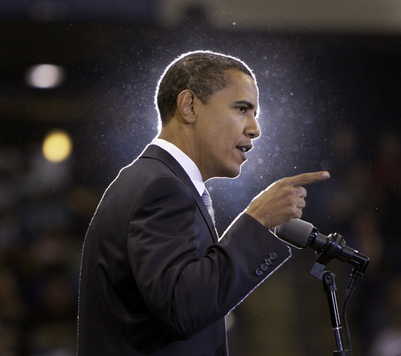

The Last Supper
The Obama campaign is now advertising "the last Dinner with Barack." In an email sent to supporters this afternoon seeking donations...http://www.weeklystandard.com/blogs/campaign-last-dinner-barack_652716.html

Many places in Prophetic Scripture tell of how the anti-christ tries to counterfeit the works and life of Jesus Christ.

=======================

Obama’s Trip to Israel: Imitation of the Triumphal Entry

President Obama’s upcoming trip to Israel is timed and choreographed so as to mimic Jesus’ (Y’Shua’s) triumphal entry into Jerusalem, and with it the predictive ‘echo’ event all Jews should recognize: Joshua’s (Y’Shua’s) crossing of the Jordan with the Israelites into the Promised Land, led by the Ark of the Covenant. Obama’s trip is also timed so as to coincide precisely with the Vernal Equinox, a pagan holiday predicated on the principle of equality and eternal balance between light and darkness — a concept wholly at odds with scripture. The president’s arrival in the land, and entry into Jerusalem marks the only year and the only day within a span of nearly two centuries when such a confluence of the Vernal Equinox and Triumphal Entry would be possible...it seems notable that the Vicar of (literally, the stand-in or substitute for) Christ, i.e., Pope Benedict XVI, should resign suddenly just six days after Obama announced his trip to Israel. The latest date rumored for the conclave to choose the next (and allegedly last) Pope to succeed him is… March 20th… the Vernal Equinox… the day Obama is set to arrive in Israel. To put it another way, the Pope’s exit process is framed by Obama’s trip. In such a context, Revelation 13 seems of increasing interest...Read this entire article here: http://newine.wordpress.com/2013/02/26/obamas-trip-to-israel-an-imitation-of-the-triumphal-entry/ ...some VERY interesting material here!

Birthing Pangs for a Two State Solution: The Struggle Between an Esau Nation and a Jacob Nation

The story from the Jerusalem Post is a BOMBSHELL story. This story, "leaks to the press" that the parameters of a Two State Solution deal ALREADY EXISTS and has been basically agreed upon by Netanyahu and Abbas...How likely is it that Obama is coming to Israel to announce this "secret deal" that has already been made? Time will tell...but the leaking of THIS STORY to the press seems to indicate that such a "closet deal" has already been signed onto by both sides and that Obama may be coming to make this announcement with much hoopla and fanfare. And, remember, he is coming not just on any RANDOM day, but on March 20, Nisan 10. This is the day that the lamb is selected for the Passover. This is the same day that Yeshua, the lamb who takes away the sins of the world, entered Jerusalem. It sure looks like Obama is stepping into the role of a FALSE MESSIAH coming to Israel to serve up on a silver seder plate the announcement of a FALSE PEACE! Remember we are warned in 1 Thessalonians 5:3-5 "For when they say, "Peace and safety!" then SUDDEN destruction comes upon them, as LABOR PAINS upon a pregnant woman, and they shall not escape. But you, brothers, are NOT IN DARKNESS, so that this Day should overtake you as a thief. For you are all sons of light and sons of the day. We are not of the night nor of darkness."...more here: http://hebrewnationradio.com/index.php?option=com_k2&view=item&id=3978:birthing-pangs-for-a-two-state-solution-what-does-it-mean?&Itemid=131

Obama: The Perfect New Super-Governor Of Jerusalem http://ivarfjeld.com/2013/03/12/obama-the-perfect-new-super-governor-of-jerusalem/

President Obama and His Israel Trip
http://www.aoreport.com/ao/prophecy-studies-mainmenu-47/1891-obamas-israel-trip-and-daniel-927-textual-analysis

=======================

Why People Around the World Should be Terrified of Obama
http://www.arewelivinginthelastdays.com/com/obama.html

Review everything on the link above and watch the YouTube Videos below, and draw your own conclusions! I report, you decide…

DID JESUS GIVE US THE NAME OF THE ANTICHRIST?
http://www.dailymotion.com/video/xqfqp1_original-updated-version-did-jesus-give-us-the-name-of-the-antichrist_news
and http://www.youtube.com/watch?annotation_id=annotation_408095&feature=iv&src_vid=sgHUZXgNAWo&v=kDRl3QNkExA

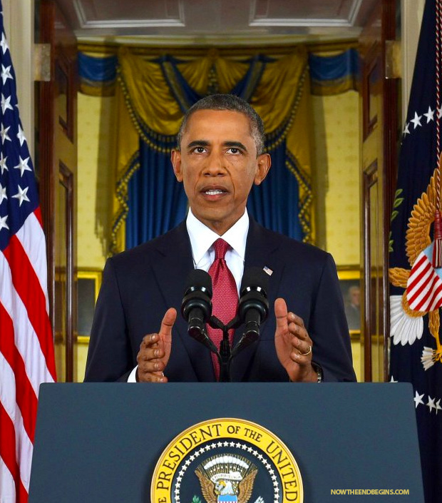

When Barack Obama was first elected in 2008, he was constantly pictured with an angelic glow surrounding him. Artists would frequently draw him with a halo surrounding his head. He was the Liberal Messiah for a lost and dying world. But something changed along the way. Halos have given way to horns. Obama, seen here giving a speech on ISIS and Islamic terrorism last night, was photographed in a startling way. He appeared to have twin horns protruding from the sides of his head in a kind of demonic apparition. Posted on 9/11/2014 http://www.nowtheendbegins.com/blog/?p=24907

This is not meant to emphatically point the finger to Barack Obama as the Antichrist, however, at the very least, he is a certainly a "type of anti-Christ" - a frontrunner (and maybe the real deal). The Bible says in II Thessalonians 2 that the power of lawlessness is already at work, but the one who now holds it back will continue to do so until he is taken out of the way... then the lawless one will be revealed. So we cannot know for sure until that absolute revealing. For sure the anti-Christ is currently at work, and I do not believe its someone so obscure that everyone is completely surprised to find out who it is...I think it we be a conformation of someone who is "already at work" ...someone who is already trying to usurp the position of God...my findings on O's comparison to The Golden Bough and his use of "Bough" in quoting Psalm 46 is chilling, as well are many of the other articles, videos and material I have posted herein. Certainly at the very least, BHO represents an important end-times warning sign or harbinger as to God's judgment on America.

~ A Watchman

