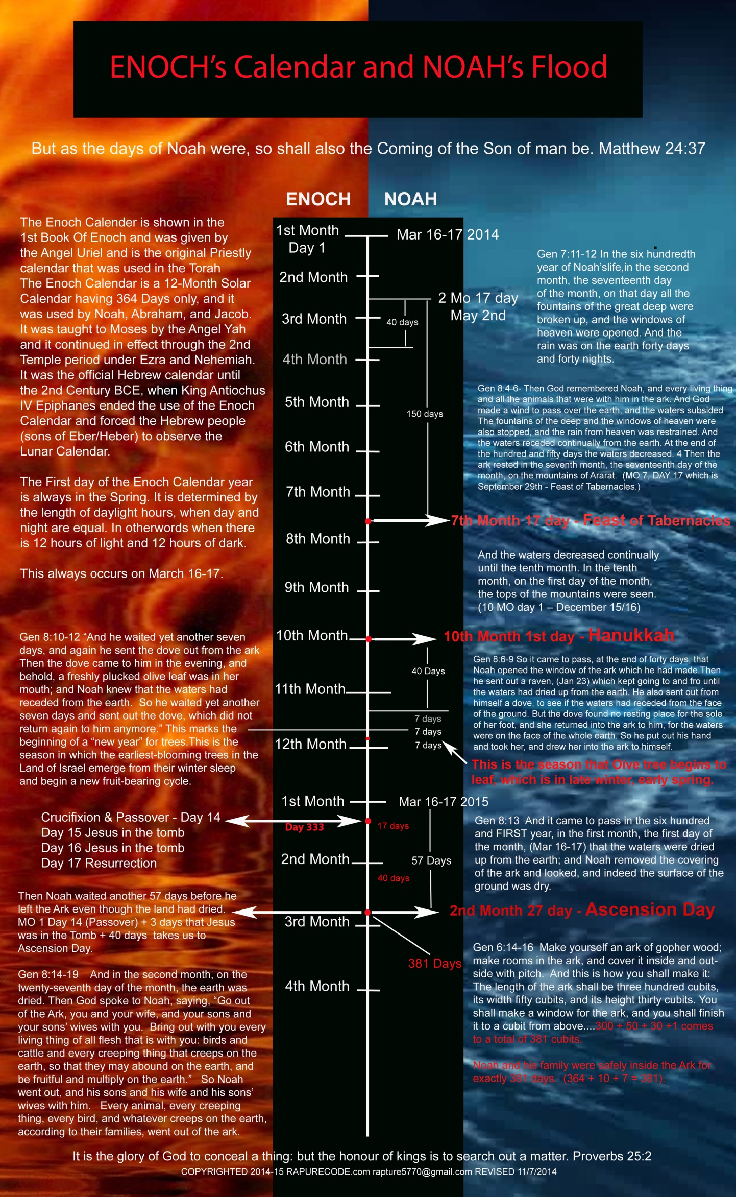

ENOCH's Calendar and NOAH's Flood Timeline

Chart and Study by Jimh RaptureCode.com 11/14/2014

This chart was setup for a 2014/2015 scenario but it can be used for any year... 2015/2016 will be no different... only the years change.
This study is a confirmation that Noah used the Calendar of Enoch. The Flood began in the spring season as you will see. The alignment of days given in the Book of Genesis about the Noah account of the Flood confirms this.

In the six hundredth year of Noah’s life, in the second month, the seventeenth day of the month, on that day all the fountains of the great deep were broken up, and the windows of heaven were opened. And the rain was on the earth forty days and forty nights.

The Rains start on 2nd Month the 17th day May 1st/2nd + 40 days = June 10th/11th the rains stops.

7th Month 17 which is 150 days when the mountain tops were seen corresponds to the First day of the Feast of Tabernacles, September 29...

10 Month 1st Day corresponds to beginning of Hanukkah, December 15/16th...
The Dove brought back a young tender olive leaf February 6th plus or minus a day. This is so very important and a major marker confirming Noah used Enoch's calendar. Trees come out of their winter sleep and begin to bloom and show their leaves at this time of the year. God set the Seasons and this is the only time possible is late winter, early spring for this to occur.. For those that claim Noah's Flood begin in the fall this would have meant that the olive tree would have had to bud in the fall not the spring which of course is impossible!
1 Year and 10 days on 2nd Month 27 day corresponds to the Day of Ascension...
Also on 333rd day of Enoch's calendar is the day Christ was crucified.
Genesis 5:32-10:1 (NKJV)
https://www.biblegateway.com/passage/?search=Genesis+5:32-10:1

And Noah was five hundred years old, and Noah begot Shem, Ham, and Japheth.

The Wickedness and Judgment of Man

Genesis Chapter 6

Now it came to pass, when men began to multiply on the face of the earth, and daughters were born to them, that the sons of God saw the daughters of men, that they were beautiful; and they took wives for themselves of all whom they chose.

And the Lord said, “My Spirit shall not strive with man forever, for he is indeed flesh; yet his days shall be one hundred and twenty years.” There were giants on the earth in those days, and also afterward, when the sons of God came in to the daughters of men and they bore children to them. Those were the mighty men who were of old, men of renown.

Then the Lord saw that the wickedness of man was great in the earth, and that every intent of the thoughts of his heart was only evil continually. And the Lord was sorry that He had made man on the earth, and He was grieved in His heart. So the Lord said, “I will destroy man whom I have created from the face of the earth, both, man and beast, creeping thing and birds of the air, for I am sorry that I have made them.” But Noah found grace in the eyes of the Lord.

Noah Pleases God

This is the genealogy of Noah. Noah was a just man, perfect in his generations. Noah walked with God. And Noah begot three sons: Shem, Ham, and Japheth.

The earth also was corrupt before God, and the earth was filled with violence. So God looked upon the earth, and indeed it was corrupt; for all flesh had corrupted their way on the earth.

The Ark Prepared

And God said to Noah, “The end of all flesh has come before Me, for the earth is filled with violence through them; and behold, I will destroy them with the earth. Make yourself an ark of gopher wood; make rooms in the ark, and cover it inside and outside with pitch. And this is how you shall make it: The length of the ark shall be three hundred cubits, its width fifty cubits, and its height thirty cubits. You shall make a window for the ark, and you shall finish it to a cubit from above; and set the door of the ark in its side.

You shall make it with lower, second, and third decks. And behold, I Myself am bringing flood waters on the earth, to destroy from under heaven all flesh in which is the breath of life; everything that is on the earth shall die. But I will establish My covenant with you; and you shall go into the ark—you, your sons, your wife, and your sons’ wives with you. And of every living thing of all flesh you shall bring two of every sort into the ark, to keep them alive with you; they shall be male and female. Of the birds after their kind, of animals after their kind, and of every creeping thing of the earth after its kind, two of every kind will come to you to keep them alive. And you shall take for yourself of all food that is eaten, and you shall gather it to yourself; and it shall be food for you and for them.”

Thus Noah did; according to all that God commanded him, so he did.

The Great Flood

GEN 7 Then the Lord said to Noah, “Come into the ark, (April 25th) you and all your household, because I have seen that you are righteous before Me in this generation. 2 You shall take with you seven each of every clean animal, a male and his female; two each of animals that are unclean, a male and his female; 3 also seven each of birds of the air, male and female, to keep the species alive on the face of all the earth. 4 For after seven more days I will cause it to rain on the earth forty days and forty nights, and I will destroy from the face of the earth all living things that I have made.” 5 And Noah did according to all that the Lord commanded him. 6 Noah was six hundred years old when the flood waters were on the earth.

7 So Noah, with his sons, his wife, and his sons’ wives, went into the ark because of the waters of the flood. 8 Of clean animals, of animals that are unclean, of birds, and of everything that creeps on the earth, 9 two by two they went into the ark to Noah, male and female, as God had commanded Noah. 10 And it came to pass after seven days that the waters of the flood were on the earth. 11 In the six hundredth year of Noah’s life, in the second month, the seventeenth day of the month…

(Using Enoch’s Calendar that would be March 16-17 (MO 1, Day 1) + 30 + 17 = May 2nd

On that day all the fountains of the great deep were broken up, and the windows of heaven were opened. And the rain was on the earth forty days and forty nights.
Rains start on May 2 + 40 days = June 11-12 the rains stops

13 On the very same day Noah and Noah’s sons, Shem, Ham, and Japheth, and Noah’s wife and the three wives of his sons with them, entered the ark— 14 they and every beast after its kind, all cattle after their kind, every creeping thing that creeps on the earth after its kind, and every bird after its kind, every bird of every sort. 15 And they went into the ark to Noah, two by two, of all flesh in which is the breath of life. 16 So those that entered, male and female of all flesh, went in as God had commanded him; and the Lord shut him in.

(May 2nd (–) 7 days = Noah enters the Ark and door is shut on April 25)

17 Now the flood was on the earth forty days. The waters increased and lifted up the ark, and it rose high above the earth. 18 The waters prevailed and greatly increased on the earth, and the ark moved about on the surface of the waters. 19 And the waters prevailed exceedingly on the earth, and all the high hills under the whole heaven were covered. 20 The waters prevailed fifteen cubits upward, and the mountains were covered. 21 And all flesh died that moved on the earth: birds and cattle and beasts and every creeping thing that creeps on the earth, and every man. 22 All in whose nostrils was the breath of the spirit of life, all that was on the dry land, died. 23 So He destroyed all living things which were on the face of the ground: both man and cattle, creeping thing and bird of the air. They were destroyed from the earth. Only Noah and those who were with him in the ark remained alive! 24 And the waters prevailed on the earth one hundred and fifty days.
(May 2nd rain began + 150 days = Sept 28 @sundown - Feast of Tabernacles Sept 29th until sundown)

Noah’s Deliverance

8 Then God remembered Noah, and every living thing, and all the animals that were with him in the ark. And God made a wind to pass over the earth, and the waters subsided. 2 The fountains of the deep and the windows of heaven were also stopped, and the rain from heaven was restrained. 3 And the waters receded continually from the earth. At the end of the hundred and fifty days the waters decreased. 4 Then the ark rested in the seventh month, the seventeenth day of the month, on the mountains of Ararat.

(MO 7, DAY 17 – Sept 29 Feast of Tabernacles)

5 And the waters decreased continually until the tenth month. In the tenth month, on the first day of the month, the tops of the mountains were seen.

(10 MO day 1 – December 15/16 beginning of Hanukkah)

6 So it came to pass, at the end of forty days, that Noah opened the window of the ark which he had made. 7 Then he sent out a raven, (Jan 23) which kept going to and fro until the waters had dried up from the earth. 8 He also sent out from himself a dove, to see if the waters had receded from the face of the ground. 9 But the dove found no resting place for the sole of her foot, and she returned into the ark to him, for the waters were on the face of the whole earth. So he put out his hand and took her, and drew her into the ark to himself.

10 And he waited yet another seven days, (Jan 30) and again he sent the dove out from the ark. 11 Then the dove came to him in the evening, and behold, a freshly plucked olive leaf was in her mouth; and Noah knew that the waters had receded from the earth. 12 So he waited yet another seven days and sent out (Feb 6-7 TUB'SHEVAT NEW YEAR FOR TREES) the dove, which did not return again to him anymore.

13 And it came to pass in the six hundred and first year, in the first month, the first day of the month, (Mar 16/17) that the waters were dried up from the earth; and Noah removed the covering of the ark and looked, and indeed the surface of the ground was dry.

But Noah waited another 57 days before God gave the word for him and his family to leave the Ark. This corresponds to Month 1 Day 14 Nissan 14 Passover) + 3 days Jesus was in the Tomb = 17 days + 40 days to Jesus' Ascension for a total of 57 days.

...and 1 YEAR 10 DAYS LATER

14 And in the second month, on the twenty-seventh day of the month, the Earth was dried.

1 month or 30 days + 27 days = 57 days on May 12
15 Then God spoke to Noah, saying, 16 “Go out of the ark, you and your wife, and your sons and your sons’ wives with you. 17 Bring out with you every living thing of all flesh that is with you: birds and cattle and every creeping thing that creeps on the earth, so that they may abound on the earth, and be fruitful and multiply on the earth.” 18 So Noah went out, and his sons and his wife and his sons’ wives with him. 19 Every animal, every creeping thing, every bird, and whatever creeps on the earth, according to their families, went out of the ark.

The Rains began and the fountains of the deep were opened on Month 2 day 17.

Then God spoke to Noah and said to come out of the ark on Month 2 day 27, 1 year and 10 days later or 374 days... Also remember door was shut by God 7 days prior to the rain starting.

Noah's total time inside the Ark was 1 year or 364 days + 10 + 7 … for a total of 381 day. Interesting is that I the pattern of the Ark corresponds to the same number. Its length is 300 cubits, its width is 50 cubits and the height is 30 cubits plus you add 1 for the window 1 cubit above. 300+ 50 +30 + 1 = 381

Month 1 day 1 - March 16-17 on Enoch’s calendar corresponds to Nisan 1 on Hebrew calendar.

Month 1 day 14 - March 30 corresponds to Nisan 14 Crucifixion and then Passover starting at Sundown

Month 2 day 27 - May 12 corresponds - Ascension Day

Hebrew Feast 2014-2015
HANUKKAH - FESTIVAL OF LIGHTS DEC 16-24 2014
CHRISTMAS 12/25/2014 A JEWISH BOY'S BIRTHDAY
TUB'SHEVAT NEW YEAR FOR TREES FEB 3-4 2015
PURIM THE STORY OF ESTER MARCH 4-5 2015
PASSOVER APRIL 3-11 2015
TISHA B'AV - DESTRUCTION OF THE TEMPLE JULY 25-26 2015
ROSH HASHANAH SEPT 13-15 2015
YOM KIPPUR - DAY OF ATONEMENT SEPT 22-23 2015
SUKKOT FEAST OF TAB SEPT 27-OCT 4 2015
SHEMINI ATZERET SIMCHAT TORAH OCT 4-6 2015

