Hi John and Doves,
PART ONE ‒ WHAT and WHO IS RESTRAINING ‘THE MAN OF SIN’
FROM BEING REVEALED?
My letters posted on Dec. 22, 2023, will provide the background material... for is written below.
The Dragon, the Beast and Babylon – https://www.fivedoves.com/letters/dec2023/ear1222-1.htm
The Dragon’s assault on Israel ‒ https://www.fivedoves.com/letters/dec2023/ear1222-1.htm
THE MYSTERY OF THE EIGHTH ITERATION OF THE BEAST (fivedoves.com) Dec. 22, 2023
BABYLON IS FALLEN, IS FALLEN, THAT GREAT CITY (fivedoves.com) Dec. 22, 2023
------------------------[]-------------------------
About this imminent end-time period, Paul says (via NKJV):
Let no one deceive you by any means; for that Day (of Christ) will not come unless the falling away (apostasy―1 Tim. 4:13; 2 Tim. 3:1‒5) comes first, and the man of sin is revealed, the son of perdition, (i.e., the man who is doomed to destruction). (2 Thess. 2:3)
And now you know what is restraining, that he (the man of sin) may be revealed in his own time.
For the mystery of lawlessness (hidden truth) is already at work; only he who now restrains will do so until he is taken out of the way. And then the lawless one will be revealed, whom the Lord will consume with the breath of His mouth and destroy with the brightness of His coming. (2 Thess. 2:6‒8)
Thus, the individual whom Paul calls the man-of-sin ― who is yet to be revealed ― fulfils a similar ‘role’ as the person described in John’s apocalyptic vision as the beast coming up out of the ‘earth’ (Rev. 13:11‒17, i.e., an earthling, born here on planet earth), who also bears the ‘title’ of ‘False Prophet’ (Rev. 16:13). He exercises all the authority of the first beast on its behalf (i.e., in ‘its’ presence, Rev. 13:12, RSV). This ‘irredeemable person’ ― who is called ‘the lawless one’ by Paul (2 Thess. 2:8‒12) ― is subject to destruction, along with those who are condemned to perish because they would not receive the love of the truth; (i.e., those who bear the mark of the beast kingdom and worship its leader Rev. 13:15‒17; 17:8a; 19:20). The False Prophet is a man (like Judas Iscariot who had no path to repentance), who will be revealed in the end time, who makes fire come down from heaven on the earth in the sight of men (likely to be a missile with a nuclear warhead, cf. 6th Seal, Rev. 6:12‒14) because of his ability to exercise the power and authority inherent in the animal-beast kingdom (Grk. ‘it’ neuter gender, Rev. 13:1‒8, RSV)
Note: The outline shape of this animal-beast kingdom has only been completely visible on a map since the fall of USSR ― that was ‘formally dissolved as a sovereign state and subject of international law ― on 26 December 1991, by Declaration No. 142-N of the Soviet of the Republics of the Supreme Soviet of the Soviet Union.’ Dissolution of the Soviet Union - Wikipedia
Subsequently, it the tripartite animal-beast shaped kingdom has appeared in the end time, sitting on the ‘territories’ of ancient Babylon (lion), Media-Persian (bear) and Macedon-Greece (leopard), which had on its back four wings of a bird... that became the four southern independent ...stan Republics, ex-Soviet Union, which completed the shape of the animal-beast kingdom between 1990‒1991. (See below)
This tripartite animal-beast acts as the earthly ‘agent’ or kingdom that mirrors the God-opposing celestial great red dragon (aka Devil and Satan), who has given ‘it’ his power, his throne and great authority, via the demons that dwell in it. (Rev. 12:3‒4a, 9; 13:2; 16:13‒14) Meanwhile, the dragon is enraged with the woman (Israel of God, Rev. 12:4b, 9b, 13, 17), and he makes war with her offspring; i.e., the Jews (who keep the commandments of God), and Christians (who have the testimony of Jesus Christ). While the dragon’s earthly ‘agent’ the animal-beast (initially opposes God and His people through persecution and war, Rev. 13:5‒7), the false prophet (i.e., the earthling, with two horns like a lamb and spoke like a dragon) exerts economic restrictions against those who do not worship (pay homage or bow down) to the animal-beast kingdom. (Rev. 13:15‒17) Later on, this trio of enemies of God are gathered via the animal-beast’s eighth alliance, at Armageddon (Rev. 16:13‒14; 17:11‒14), to fight the Lamb and His called, chosen and faithful saints.
This mute animal-beast ‘it’ shaped kingdom is also given ‘a mouth’ i.e., a spokesperson (Rev. 13:5), through which to ‘blaspheme’ God via its idolatrous words and worship; (cf. the loud call to prayer or salat from the Islamic Mosques’ minarets that takes place all over the world called the adhan, causing Muslims to bow down via the Qibla in the direction of Mecca five time a day! The dual symbolism of the ‘false prophet’ from the ‘earth,’ and the animal-beast from the ‘sea,’ (i.e., kingdom land) represents the symbiotic relationship that existed ― and continues to exist, within religious idolatry and the Muslim-kingdom pagan-governments ― during the New Testament age.
At the end of the ‘Age of the Gentiles’ the animal-beast’s appearance is recognizable via the three ancient territorial kingdoms called the lion, bear and leopard (Dan. 7:4‒6, 12) on which it sits, which are morphed together via the different parts drawn from those ancient kingdoms (Rev. 13:1‒2) to form the outline or shape of the latter-day beast on our modern territorial maps.
Note: To help our contemporary understanding: the beast from the sea is a territorial land mass that rose up from the sea (as land does), at the eastern end of the Mediterranean Great Sea (called the Levant). This beast is seen to have seven ‘heads’ that represent the seven kingdoms that once possessed part or all of that territory, which accumulated via the Babel, Assyria, Neo-Babylon, Media-Persia, Macedon-Greece, Roman-Byzantine, and SUNNI Ottoman (x 2) ISIS Empires. The beast also has ten ‘horns’ (smaller nations) that have accrued out of that animal-beast shaped territory i.e., Türkiye, Iran, Afghanistan, Pakistan, Iraq, Syria, Jordan, Lebanon, northern Egypt, and eastern Libya, which are the Muslim nations that surround Israel today.
It is from these seven former kingdom territories and the ‘10 horn/nations’ (listed above) that ‘the man of sin’ aka the false prophet, (a latter-day descendant of Muhammad: aka The Seal of the Prophets), will lead the eighth alliance of combatants (Rev. 17:11), who are ‘gathered’ ― by the demonic spirits like frogs that inhabit the evil trio to assemble at Armageddon, who participate in the battle of that great day of God Almighty. (Rev. 16:13‒14) Thus, the false prophet will ‘perform signs’ on behalf of the animal-beast kingdom (so that he even makes fire come down from heaven on the earth in the sight of men, Rev. 13:13; 16:14), as ‘great signs’ to assemble the Jihadist combatants.
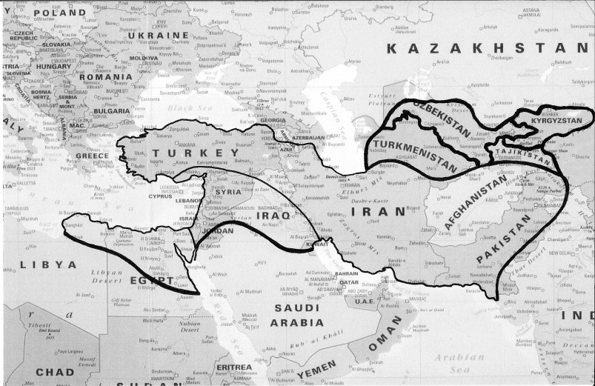
Now the beast which I saw was like a leopard with four wings of a fowl on its back [Macedon-Grecian Empire, Dan. 7:6] his feet were like the feet of a bear [Media-Persian Empire, Dan. 7:5] and his mouth was like the mouth of a lion. [Babylonian Empire, Dan. 7:4] The dragon gave him his power, his throne, and great authority. (Rev. 13:2)

During Old Testament times, Daniel said that these three old empires (aka Lion, Bear and Leopard), would have their dominion taken away, yet their lives [would be] prolonged for a season and a time (Dan. 7:12) so that their various parts could reappear in the New Testament, (in reverse order, as leopard, bear, lion; looking backward in time), in Revelation 13:1‒2 in John’s vision of the animal-beast. Thus, the shape of this tripartite territorial entity called the animal-beast can be recognised on the map of Asia Minor, Middle East, Central Asia and North Africa, because that shape contains the seven ‘heads’ (i.e., historic mountains or kingdoms) that have existed within that territory since the first post-flood kingdom of Babel. Consequently, although the Roman empire began in Italy in Europe, that continent was not part of the Lion, Bear and Leopard Empires’ domain ― so only after Rome’s capital was moved eastward to Constantinople after AD 476, did the Eastern Roman Empire become the 6th ‘head’ on the animal-beast ― where it continued as New Rome, the Roman-Byzantine Empire for 1,000 years. New Rome was finally conquered by the Sunni Muslim Turkic Ottoman Empire in 1453 → when it became the 7th ‘head’ on the animal-beast until it was mortally wounded in WWI, and was dis-established in 1922. Unfortunately, the 7th ‘head’ on the animal-beast with the ‘mortal wound’ was healed 92 years later, by the resuscitated (x 2) Sunni Islamic State, ISIS Caliphate. (2014‒2017; Rev. 13:3, 5) Hence, the beast that was, and is not... ascended out of the bottomless pit, and it went to perdition (destruction, Rev. 17:8a) on December 9‒10, 2017, exactly 100 years after the Ottoman Empire was defeated in Jerusalem in 1917. http://beastandbabylon.com
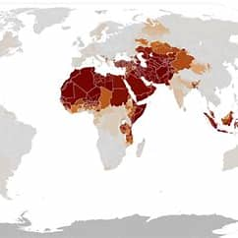
It is clear from scripture that the False Prophet’s main task in the end times as a quasi-religious and revolutionary person (Rev. 13:11‒17), is to promote the imperialistic advance of the animal-beast’s idolatrous government (Rev. 13:1‒8; 17:9‒10) ― via its long-lived existence in the great city called Mystery Babylon in the wilderness (Rev. 17:3), (i.e., Mecca, containing its ‘throne’ and ‘base’) ― while expanding its hegemony over the world. Thus, the false prophet exercises all the authority and power given to the (territorial) animal-beast kingdom, by the dragon.
However, it is also clear from modern political science, that the animal-beast shape (above) barely hosts a quarter of the world-wide Islamic community (Ummah) today: →
Muslim Ummah – Present day
numbering 2.06 billion peoples, multitudes, nations and tongues, who belong to the expansionist political-religious –militant system called Muhammadanism, which was originally founded in Mecca, in the 7th Century AD. The bulk of this Ummah now extends from Türkiye to Pakistan, and from Kazakhstan through the Middle East to the whole northern half of Africa, the Horn of Africa, and across to Indonesia.
So now, during the end-time period that is currently upon us ― following the recent revival of radical Islam; via the terrorist groups called Al Qaeda and the Islamic State, ISIS Caliphate, and the appearance of multiple other Jihadist groups during first few decades of the 21st Century ― we wait for the latter-day False Prophet, (the man of sin, aka the lawless one), who will inherit the mantle of Muhammad (aka the Seal of the Prophets), to be revealed.
Consequently, the False Prophet, together with the leader of the eighth beast alliance, (who is referred to as ‘himself’ Rev. 17:11; cf. Rev. 9:11), plus the dragon, are able to ‘perform signs’ through the frog-like demonic spirits that inhabit them, by making fire come down from heaven on the earth in the sight of men. (Rev. 13:13; 16:13‒14) These signs are broadcast to the whole World, in order to muster terrorist Jihadist combatants ― from the seven former head/kingdom territories and the ten horn-kings (without kingdoms, Rev. 16:14; 17:11‒13) ― and mobilise the eighth alliance when they receive authority for one hour as kings with the beast. Then they must act... first against the harlot woman aka the great city, to burn her with fire (in accordance with God’s will and prophetic word, Rev. 17:17); and then to make war with the Lamb, and those who are with Him who are called, chosen, and faithful (Rev. 17:16, and 14), during which battle they are overcome (Rev. 19:19‒21)
And now you know what is restraining, that he (the man of sin, aka son of perdition, who is doomed to destruction) may be revealed in his own time.
For the mystery of lawlessness (hidden truth) is already at work; only He who now restrains will do so until He is taken out of the way. And then the lawless one will be revealed, whom the Lord will consume with the breath of His mouth and destroy with the brightness of His coming.
The coming of the lawless one is according to the working of Satan... (2 Thess. 2:6‒9a)
He performs great signs, so that he even makes fire come down from heaven on the earth in the sight of men (Rev. 13:13);
For they are spirits of demons, performing signs, which go out to the kings of the whole world to gather them to the battle of that great day of God Almighty (Rev. 16:14)
...with all power, signs and lying wonders, and with all unrighteous deception among those who perish, because they did not receive the love of the truth, (the Gospel), that they might be saved.
And for this reason God will send them (Muslims) strong delusion, that they should believe the lie, that they all may be condemned who did not believe the truth but had pleasure in unrighteousness. (2 Thess. 2:9b‒12)
------------------------[]-------------------------
PART TWO... to come: ‘what’ is restraining ‘the man of sin,’ and
‘who’ is restraining him until he is taken out of the way?

God Bless You in your search for the truth,
EAR

