Ezekiel 1:11-28
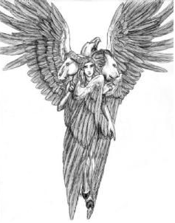
9 Types of Angels - The most influential Christian angelic hierarchy was that put forward by Pseudo-Dionysius the Areopagite in the 4th or 5th century in his book De Coelesti Hierarchia (On the Celestial Hierarchy). Dionysius described nine levels of spiritual beings which he grouped into three orders. Jewish tradition places them as the second lowest rank.

Highest order
The cherubim are the most frequently occurring angels in the Bible (appearing 91 times), appearing as the first angels mentioned. They appear in Genesis as the Guardians of the Tree of Life. In Ezekiel they help transport the Throne of God. In Exodus, Moses is told to make multiple images of cherubim and place them on the Mercy Seat of the Ark of the Covenant. They are also images found on the curtains of the Tabernacle and in Solomon’s Temple.

Seraphim
Cherubim
Thrones

Middle order
Dominions
Virtues
Powers

Lowest order
Principalities
Archangels
Angels

¹¹ Thus were their faces. Their wings stretched upward; two wings of each one touched one another, and two covered their bodies.
The effect was to form a box, with a cherubim at each corner. Or one could symbolically draw them out to show a cross. Cherubim were the first angels mentioned in the Bible in Genesis 3:24, “So He drove out the man; and He placed cherubim at the east of the Garden of Eden, and a flaming sword which turned every way, to guard the way to the tree of life.” They are also among the last mentioned in Revelation 4:7, “The first living creature was like a lion, the second living creature like a calf, the third living creature had a face like a man, and the fourth living creature was like a flying eagle.”
In short, the cherubim are seen when Man is removed and barred from the Garden of Eden and the Tree of Life and are seen again in heaven shortly after the Rapture (as envisioned by John in Revelation). I find that interesting.

¹² And each one went straight forward; they went wherever the spirit wanted to go, and they did not turn when they went.
¹³ As for the likeness of the living creatures, their appearance was like burning coals of fire, like the appearance of torches going back and forth among the living creatures. The fire was bright, and out of the fire went lightning. ¹⁴ And the living creatures ran back and forth, in appearance like a flash of lightning.

The cherubim always moved straight ahead. Their “wheels” appeared to be gyroscopic in effect. They never turned their faces. In the drawing below, you can see a depiction of this. The cherubim were created in the image of a man, moving in service to the Father, under and with His authority and reflecting His Spirit.
From Walvoord, I quote, “This speaks of intensity. The living creatures weren’t just flickering. They were burning, ignited, on fire. One evangelist of old was asked how he attracted so many people to come and hear him preach. ‘It’s very simple,’ he answered. ‘I pray in my closet until I’m ignited. And then I come out and people come to see me burn.’”
Walvoord adds that God doesn’t want and can’t use a lazy man. Lightning speaks of incredible speed and brightness. These are the qualities that God seeks in those who profess to love Him.
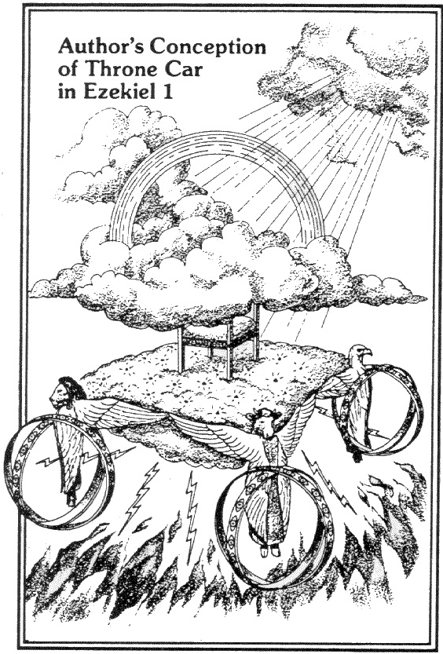
An image of “man”, moving in service and authority and filled with the spirit of God. AMAZING!
The wheels were like gyroscopes, able to move in any direction without turning.
Christ hung on the cross, with all authority, in service to the Father, as a man filled with the Holy Spirit.
Man
Man

Authority
Authority
Authority
Service
Spirit
Authority
Service
Service
Man
Man
Service
Man
Spirit
Authority
Spirit
Man
Service

Authority
The cherubim moved in the form of a cross!
Service

¹⁵ Now as I looked at the living creatures, behold, a wheel was on the earth beside each living creature with its four faces. ¹⁶ The appearance of the wheels and their workings was like the color of beryl, and all four had the same likeness. The appearance of their workings was, as it were, a wheel in the middle of a wheel. ¹⁷ When they moved, they went toward any one of four directions; they did not turn aside when they went. ¹⁸ As for their rims, they were so high they were awesome; and their rims were full of eyes, all around the four of them.

Here we see that the wheels were described as gyroscopes, or wheels within wheels and covered in eyes. The wheels had the ability to move in any direction at any moment and were covered in eyes which speaks of God’s omnipresence and omniscience.

¹⁹ When the living creatures went, the wheels went beside them; and when the living creatures were lifted up from the earth, the wheels were lifted up. ²⁰ Wherever the spirit wanted to go, they went, because there the spirit went; and the wheels were lifted together with them, for the spirit of the ^{[d]}living creatures was in the wheels. ²¹ When those went, these went; when those stood, these stood; and when those were lifted up from the earth, the wheels were lifted up together with them, for the spirit of the ^{[e]}living creatures was in the wheels.

This conglomeration of the four cherubim and wheels is depicted as acting as one unit. In this passage, we see the Ezekiel is shown a vision of God’s Throne Chariot. He sees the God of the universe on a thoroughly mobile platform and in complete control of the cherubim chariot.

²² The likeness of the ^{[f]}firmament above the heads of the ^{[g]}living creatures was like the color of an awesome crystal, stretched out over their heads. ²³ And under the firmament their wings spread out straight, one toward another. Each one had two which covered one side, and each one had two which covered the other side of the body. ²⁴ When they went, I heard the noise of their wings, like the noise of many waters, like the voice of the Almighty, a tumult like the noise of an army; and when they stood still, they let down their wings. ²⁵ A voice came from above the firmament that was over their heads; whenever they stood, they let down their wings.

Here we see the mention of a firmament above them, which is described as incredibly beautiful. Again, this reminds us of the formation of the universe by God in Genesis on the second day of Creation (Gen 1:6-7). In this depiction of the firmament or expanse, we see something solid which supported the waters above it. Ezekiel describes it as looking like ice crystals. In Revelation, John refers to the expanse around God’s throne as “clear as crystal”.
The beating of the cherubim’s wings sounded like rushing water and was as intense as the voice of God. To Ezekiel, this chorus of sound was likened to the din of an army in battle. The sound only stopped when the cherubim lowered their wings.

²⁶ And above the firmament over their heads was the likeness of a throne, in appearance like a sapphire stone; on the likeness of the throne was a likeness with the appearance of a man high above it. ²⁷ Also from the appearance of His waist and upward I saw, as it were, the color of amber with the appearance of fire all around within it; and from the appearance of His waist and downward I saw, as it were, the appearance of fire with brightness all around. ²⁸ Like the appearance of a rainbow in a cloud on a rainy day, so was the appearance of the brightness all around it. This was the appearance of the likeness of the glory of the Lord.

All of heaven stops when God speaks. Just so, when the cherubim stopped the movement of their wings, God spoke. Ezekiel sees what he perceives as a throne of sapphire (or lapis lazuli) as he looks up. Upon this throne is a personage that Ezekiel describes as looking like a Man (In His Image are we made). Ezekiel’s vision is drawn first to the upper part of His body and then to the lower part of His body. Interestingly, although, Ezekiel can clearly see and describe in detail what a cherub looks like, he is only able to describe this “Man” as glowing metal and fire. God’s glory was so incredibly bright, that Ezekiel could only see his form before he was forced to look down. At this point, Ezekiel notices a radiance, like a rainbow. The rainbow is a refraction of the light of God and reminds us of His promise. Again, the apostle John repeats this description in Revelation 4:3.
Ezekiel makes very clear who he believes this vision to be. He describes it as the appearance of the likeness of the glory of the Lord. Ezekiel refers to the Lord’s glory 16 times in Ezekiel. It should be noted that Ezekiel did not see God directly….no man can. That would cause immediate death (Ex 33:18-23; John 1:18).
In response to this vision, Ezekiel prostrates himself before God. This is a common occurrence in the Bible when faced with the very presence of God. It would certainly be mine!

