DOVES MESSAGE 6:

I LOVE THIS MESSAGE FROM GOD! LISTEN UP SAINTS & DOVES!

EACH BLOOD MOON AND THE MID-POINT OF THE 2014/ 2015 BLOOD MOON TETRAD, THE GREAT ECLIPSE, AND THE GREAT SIGN SPEAK WITH WORDS THAT BEFORE WERE “SHUT-UP” WORDS OF DANIEL 12:4

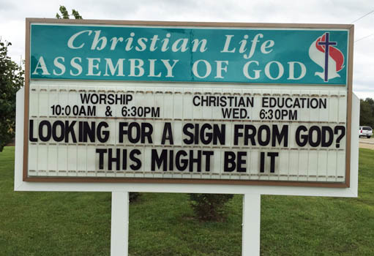

7 WORDS [1] [2] [3] [4] [5] [6] [7]

Remember the message from God from the meanings of the names of ALL OF our 10 ancestors, WE ALL HAVE THESE GUYS IN COMMON!!!! in Genesis 5? "Man is appointed mortal sorrow but the blessed God shall come down teaching that His death shall bring the repentant rest." I know you were saying it with me as we got to the end.

That's the meaning of the names in Genesis 5. Thanks Chuck Missler! See you soon.

There is a message in the words revealed by day counts from the 5 dates of the Great Tetrad ([1]Mid-Point, [2] Passover 14, [3] Tabernacles 14, [4] Passover 15, [5] Tabernacles 15, [6] Great American Eclipse, [7] AND OF COURSE, Great Sign.

Here is how I would put those words from the day counts in those dates in a sentence....

"SAINTS, I WILL [1] COMPLETE YOUR FINAL DELIVERY IN SAFETY. I [2] SEEK OUT MY [3] GLORY, IN THE HOLINESS I HAVE GIVEN YOU [4] WHEN THE SPIRIT INDWELT YOU. OH SAINTS, YOU WILL BE [5] FED WITH EVERYTHING YOUR SOUL DESIRES. YOU WILL SEE ME [6] UNVEILED AS THE KING, AND YOU WILL BE UNVEILED AS THOSE WHO WILL RULE WITH ME. GET READY! WHEN I [7] SHOUT OUT THE LAST TRUMP, YOU WILL SHOUT UP [7] WITH PRAISE."

That is the message of 7 words from the Blood Moon Tetrad dates of the mid-point, the 1st, 2nd, 3rd, 4th blood moon, the Great eclipse and the Great Sign. It is beautiful. These are signs in the Heavens and our Lord said, when these things begin to happen...[all the stuff they talk about as they look around] HE SAID "LOOK UP!!!!!"

OH YES! Sorry I nearly forgot. The day counts those words were from were only if 1 thru 7 were day counts to THE FIRST DAY OF THE WEEK, July 29, 2018. Day 308 of Mary's pregnancy, just after that big lunar eclipse. Who knows?

Blessings Saints. Soon we rise and shine.

All the detail information for these words is set forth in Post #306.

#313

