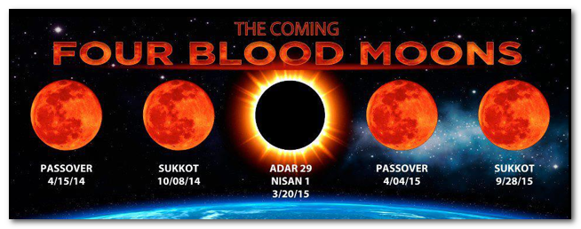
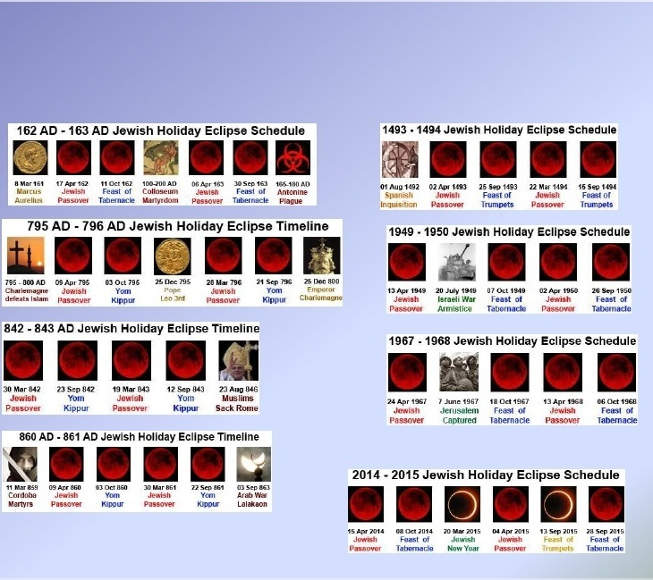

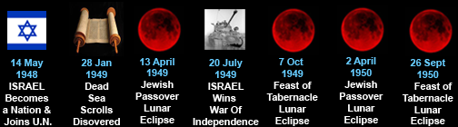

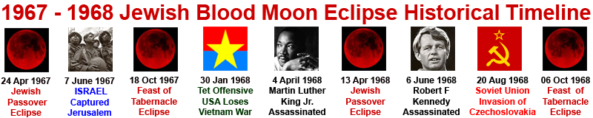
Joel 2:31“The sun shall be turned into darkness, and the moon into blood, before the great and the terrible day of the LORD come.”
Acts 2:20 “The sun shall be turned into darkness, and the moon into blood, before that great and notable day of the Lord come.”
Revelation 6:12:“and the sun became black as sackcloth made of hair, and the whole moon became like blood”.
Genesis1:14 “And God said, Let there be lights in the firmament of the heaven to divide the day from the night; and let them be for signs, and for seasons, and for days, and years.
A blood moon also known as a lunar eclipse by itself isn’t rare, but when they fall on God’s appointed days consecutively over two years then that is extremely rare. Another name for a group of four blood moons is a (tetrad) .This same rare alignment of blood moons falling on Gods appointed days has only happened 8 times since Jesus’ crucifixion and this is the 9th^{th} time, after this it won’t happen again for over 600 years. Every single time it’s happened something prophetic has occurred along with it.
It is said by many biblical scholars that usually a blood moon falling on four Jewish appointed days over two years is a bad sign for Israel and its people. Furthermore if a solar eclipse also occurs, this is a signal for an upcoming catastrophic event for the whole world. It is not a coincidence that these moon alignments all fall on God’s appointed days.

What’s even more unique about this one is that there are solar eclipses tied in between this blood moon tetrad which has never happened before in history. The next prophetic event which is set to happen that involves Israel and the whole world is the rapture of the church. This event will be followed by the beginning of the 7 year tribulation which is mentioned in Daniel 9:27, where it states:

He will confirm a covenant with many for one week (seven years).

The 7 year Tribulation is a relatively short period of time where God will pour out his wrath on the earth. Everyone will experience worldwide hardships, natural disasters, famine, war, pain, and suffering, which will wipe out more than 90% of all life including mankind on the earth before the second coming takes place. There also will be terrible persecution against Christians and Jewish people; it will be the worst time in the history of mankind!

God is blatantly using these moon alignments as signals to warn us that these things are extremely close. When one looks into the meaning of the blood moon tetrad and begin to understand the patterns that are within these signs that God has given us, one will find that there is a high possibility that a severe stock market crash may take place before the rapture (a snatching away of the church from the earth by God) could happy very soon! After this event the 7 year tribulation (the pouring down of God’s wrath on the unbelieving world) will begin!

It is not being stated that a stock market crash is definitely going to happen, but the rapture of the church and the great tribulation where God’s wrath will be poured out on all unbelievers definitely will!

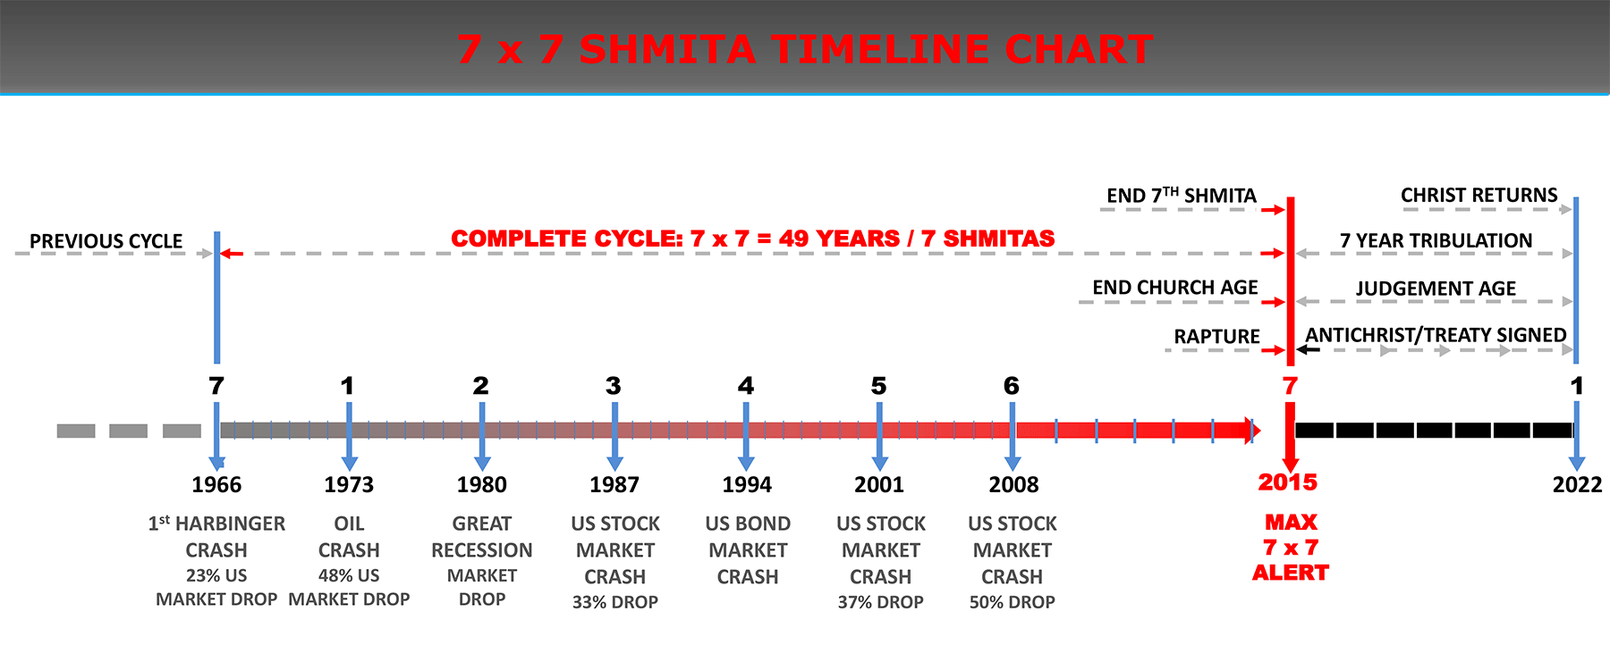
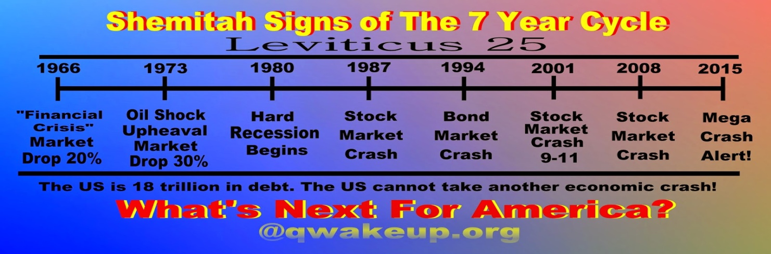

Referring to the chart above the stock market has crashed a few times before, but only by a few points. You can also see the 7 year pattern of when these stock market crashes occur. Some people speculate that these things will begin to unravel in the fall of 2015 based on the pattern that keeps occurring. The worst one we have ever experienced is The Great Depression and that was a severe worldwide economic collapse in the decade preceding World War II.

The timing of the Great Depression varied across nations, but in most countries it started in 1930 and lasted until the late 1930s or middle 1940s.

People had to live off porridge and rations of food and nearly everyone lost their jobs. Now if the stock market crash that I’m talking about really does happen it is likely it will be the worst stock market crash in our life and it could possibly cause a global economic collapse. This would mean a food shortage and problems with running water and Electricity and Gas supplies.

As this will be unable to be corrected, everyone including the government will be in a state of a panic and consequently this is where the Antichrist comes in.

He will be a man of peace who will rise to power and will claim to be able to sort out the world’s problems he will also explain away the rapture make up a huge deception as to what actually happened . He will mediate a 7 year peace treaty between Israel and many of the different nations and the world will look upon him as a saviour to the world. This treaty is what initiates the start of the 7 year tribulation.

He will sort out the world’s economic issues by turning all the money into a one world global currency.

The Great Tribulation is the last half of the Tribulation period, three and one-half years in length. It is distinguished from the Tribulation period because the Beast, or Antichrist, will be revealed, and the wrath of God will greatly intensify during this time.
Then 3.5 years into the tribulation the Antichrist will enforce his mark (mark of the beast) in which no one will be able to buy or sell without it and all people will be forced to worship him. The Bible warns that if anyone worships the antichrist and takes the mark of the beast which is the number. Whoever worships the beast and receives his mark they will suffer eternally in the lake of fire. The following Scripture passage makes this clear:

If anyone worships the beast and his image, and receives a mark on his forehead or on his hand, he also will drink of the wine of the wrath of God, which is mixed in full strength in the cup of His anger; and he will be tormented with fire and brimstone ( Revelation 14:10).

During the great tribulation He will also break the peace treaty with Israel and ¼ of the world’s population would have already died because of the wars that the antichrist will cause and because of God’s Judgments.

For those who are left behind there might be a second chance for them to be saved even if they rejected Christ before the rapture. Many Christians believe that there will be no second chance for those who rejected the gospel before the rapture although there is no strong scriptural basis to support this view but it still could be true. But nevertheless sadly it is unlikely that anyone will get saved during this period of time due to the deception and severe persecution of Christians and their refusal to take the mark and worship the antichrist many of them will be beheaded.

God is giving us ample warning because He does not want anyone to be condemned through the deception of the antichrist and be cast into to the lake of fire. Our Lord stated the following in John 3:16:

For God so loved the world, that he gave his only begotten Son, that whosoever believeth in him should not perish, but have everlasting life.

Concerning the Antichrist, the Scripture also chillingly states:

And then shall that Wicked be revealed, whom the Lord shall consume with the spirit of his mouth, and shall destroy with the brightness of his coming:
Even him, whose coming is after the working of Satan with all power and signs and lying wonders,
And with all deceivableness of unrighteousness in them that perish; because they received not the love of the truth, that they might be saved.
And for this cause God shall send them strong delusion, that they should believe a lie:
That they all might be damned who believed not the truth, but had pleasure in unrighteousness (2 Thessalonians 2:8-12).

If you are reading this and you do no know Jesus as your Lord and Saviour, He is calling you to repentance in-order that you can love Him and escape these terrible things that are reserved for those who have rejected His mercy. Here is a simple prayer of repentance for your salvation. All you have to do is ask the lord wholeheartedly to forgive you and save you from your sins, the gift of eternal life is free to all who will accept it. I recommend that you do it now while you still have the time. If you do not know how, just repeat the following prayer:

Dear Lord,
I admit that I am a sinner. I have done many things that don’t please you. I am sorry and I repent. I ask you to forgive me. I believe that your son Jesus Christ died on the cross for me and rose from the dead 3 days later to pay the penalty for my sins, to save me. You did what I could not do for myself. I come to you now and ask you to take control of my life, I give it to you. Help me to live every day in a way that pleases you. I love you, Lord, and I thank you that I will spend all eternity with you in Jesus’ name amen.

If you have prayed this prayer from your heart and meant it, the Bible says that you have been forgiven of your sins and now you are saved.

If you have any questions feel free to ask. I hope that you have learned something from this post.

For more information we have provided a few video links below for better understanding, please be sure to watch them in the given order.
https://www.youtube.com/watch?v=fGY_bk5SGaQ
https://www.youtube.com/watch?v=8QXc6BdRlOQ
https://www.youtube.com/watch?v=5VsKQQc57IQ
https://www.youtube.com/watch?v=1srPleJ1zfo
https://www.youtube.com/watch?v=oq0iaeA4cYo
https://www.youtube.com/watch?v=CIK5NK0SUz0
https://www.youtube.com/watch?v=WY2Ik4Zlo1Mh
https://www.youtube.com/watch?v=Ck6aji4bdWU

