More revelation
“Concepcion” Earthquake
188 & 656
Signals of our Dissappearance!
GREAT SIGN OF THE END OF THE CHURCH AGE & BEGINNING of LIFE for ISRAEL!!!
9/3/11
New Information added on 9/10/11

G#188 Shimmering/Glittering word (we all have a part/piece to God’s Divine Revelations! Thank you Lord JESUS!

The Number 188 is an interval of days between Earthquakes.
3 major Ring of Fire Quakes.
Concepcion Chile
ChristChurch NZ
Sendau Japan
9/2/11 13 days till the 188th day again, ALASKA has a 7.1 earthquake close to the very point of destination the 4th earthquake near California Coast.
Time of Earthquake 6:55 am EDT.
#655
ONLY ONE MENTION in OT and ONE in NT!
“FITLY”
Proverbs 25:11
Gematria 2115
“A Word FITLY Spoken is like APPLES of GOLD in PICTURES of SILVER.”
SHIMMERING IS GOLD, GLITTERING as a SIGN!!!
The Sign is upon us Doves!
H#211 is GOLD
1st mention in Gen. 2:11, & 212.
(4 RIVERS are mentioned in this scripture and the Lord has lead me to study it about 1 month ago. Reagarding the End from the Beginning and that these are 4 waters that go out from the Garden of Eden! They parted and all have names with meanings.)
There is only ONE other scripture with the same gematria 655.
Where is it found?
IN THE VERY CENTER OF THE BIBLE!
PRECIPICE DREAM 11/16/08
Titanic America is soon to SINK again!
A GREAT REVELATION NOW!!!
Calculated the time:
Sept. 1 I too a picture of the Sun and a Sign of the Son of Man with a SWORD JUDGMENT appeared! The Lord began to speak to me in dreams and numbers on this date.
Alaska Earthquake day.
September 2 and 6:55am
September 2, 2011
+ 656 Hours (DISSAPPEAR)
September 29, 2011
2:55pm
PSALM 118:8!!!!!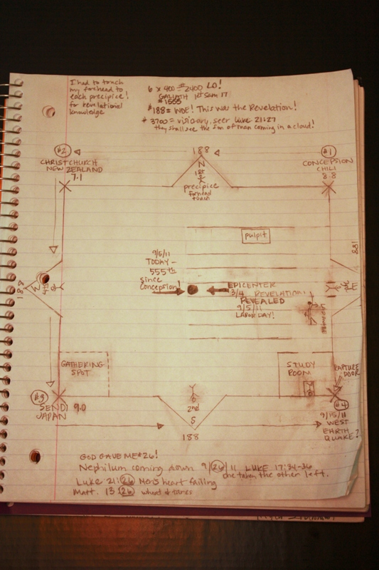
Figure 1 PRECIPICE DREAM 11/16/08
Next Earthquake will be in our Nation and will DIVIDE it ASUNDER!
H#914 BADAL- DIVIDE, SEPARATION
H#915 BADYL (BAD DEAL!) PART /PIECE
H#996 ASSUNDER –DESTRUCTION; DESOLATION

This is a Revelation from the Lord, as the gematria is direct hit to the TIME of Alaska Earthquake!
The Words “Six Hundred Fifty Five” are only ONE MENTION!
Nehemiah 7:20
“The Children of Adin Six Hundred and Fifty Five.”
Gematria of THIS VERSE?
2000!
The Gentile Age \ COMPLETE/FINISHED/ END/ IS COMMENCED!
#7650 is COMPLETION!
1999/2000
#5760

6:55 Alaska 9/2/11 Earthquake
H#655 OPHEN – To Turn, REVOLVE, that is a SEASON!
This is THE SEASON for a WORD FITLY SPOKEN!!!

H656 APHES -
H656
אפס
'âphês
aw-face'
A primitive root; to {disappear} that {is} cease: - be clean gone (at an {end} brought to {nought}) fail.

(God gave me this one after 9/11/99
*Psalm 12:1 only mention of this word FAIL and it means Dissappear, CEASE.

PACAC #6461
APHES #656
“Help O God, For the godly man CEASETH, for the FAITHFUL FAIL (6461) among the children of men.”

Now God’s turning the SEASON, and HIS HEART unto HIS WIFE, who is adulterating herself with BARAK, the ANTI CHRIST.
Here is the PROOF of what the LORD has Spoken!
Abraham to Christ is 2030 years.
Remember the First Earthquake of this number 188? Concepcion? All 3 have made a perfect square in the ring of fire area. The final 188 day interval will end on September 15th . On the California Coast in the Pacific.

ABRAHAM to CHRIST years:
#2029 #2030 #2031
H2030
הרי הרה
hâreh hârîy
{haw-reh'} haw-ree'
From H2029 ; pregnant: - ({be} woman) with {child} {conceive} X great.

H2029
הרה
hârâh
haw-raw'
A primitive root; to be (or become ) {pregnant} conceive (literally of figuratively): - {been} be with {child} {conceive} progenitor.

H2031
הרהר
harhôr
har-hor'
(Chaldee); from a root corresponding to H2029 ; a mental conception: - thought.

The Earthquakes started in the ASCENCION Island with CONCEPCION!
The Clock for Israel is pick back up in God’s timeline, as the Age of the Gentiles is FINISHED!
We are Eye Witnesses to this most AWESOME TIME IN HISTORY!
In the Greek for these same numbers we see this is what God has to say!
2030 years
from ABRAHAM – Christ’s BIRTH

#2030
ἐποπτης
epoptēs
ep-op'-tace
From G1909 and a presumed derivative of G3700 ; a looker on: - eye-witness.

2029
ἐποπτεύω
epopteuō
ep-opt-yoo'-o
From G1909 and a derivative of G3700 ; to {inspect} that {is} watch: - behold.
3700 is the word for a Prophet.

2031
ἔπος
epos
ep'-os
From G2036 ; a word: - X say.

“A Word FITLY SPOKEN is like APPLES of GOLD in Pictures of Silver.”
Pictures of SILVER
Something new I discovered is that JOEL SILVER is the producer of the MATRIX movie.
Matrix is the WOMB!
“Silver Pictures” were descending CODE on a computer Screen.
All my studies wouldn’t be possible without the use of the computer!
The Word is so complex and is written in a mytery form of Code. The last days Knowledge has increased and the Book of Daniel is decoded for us.
We are going to Witness the Greatest EVENT in HISTORY SAINTS!!!
END OF THE CHURCH AGE, and THE CONCEPTION OF ISRAEL’S MESSIAH!!!!

SIGN OF THE END and the BEGINNING!!!!!!

THE Tribulation is according to God Almighty in His Word and indicated through His Signs in the Earth, is to Commence this Turn of the SEASON!

SEPTEMBER!

Next day another Earthquake at 9:55!
7.0 VANUATU
The 9:55 a.m. Sunday (2256 GMT Saturday) quake was deep, some 132 kilometers (82 miles) below the surface, the USGS said.
The USGS said the quake hit some 348 kilometers (216 miles) southeast of Port Vila, the capital of Vanuatu, and some 1,860 kilometers (1,155 miles) northeast of Brisbane, Australia.
H955 = SHAME
H956 = Lodge overnight(BUTH/booth)
H 954 = BE Pale/Ashamed (BUSH)
G955 = SATAN
G956 = MISSLE/ARROW

The Lord gave me today 9.10.11
This number 1110
Isa 24:1
Behold, the LORDH3068 maketh the earthH776 empty,H1238 and maketh it waste,H1110 and turnethH5753 it upside down,H6440 and scattereth abroadH6327 the inhabitantsH3427 thereof.
On both sides of this number we have the coming of the false prophets:
Balaam and Balak!
1109 1111
Nah 2:10
She is empty,H950 and void,H4003 and waste:H1110 and the heartH3820 melteth,H4549 and the kneesH1290 smite together,H6375 and much painH2479 [is] in all loins,H4975 and the facesH6440 of them all gatherH6908 blackness.H6289
Knees there is the word: BARAK!

